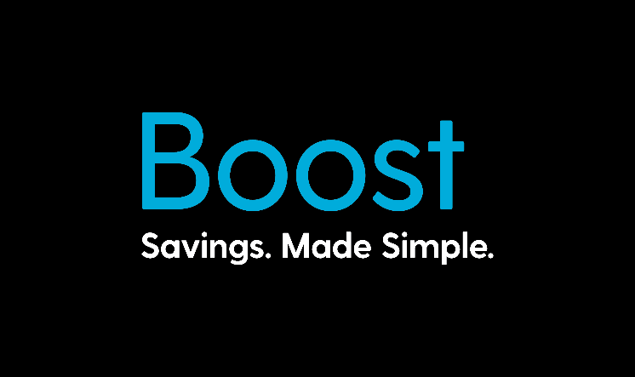
Hi First Name,

Company Name is excited to announce a new employee benefits programme for our staff called Boost!

About Boost
Boost is a benefits programme that lets employers reward their people with discounts and special offers at NZ retailers and service providers.

Boost is easy to use. Simply download the mobile app, register your details and you’re good to go! You will receive email updates on the latest limited time offers as well as access to everyday deals.
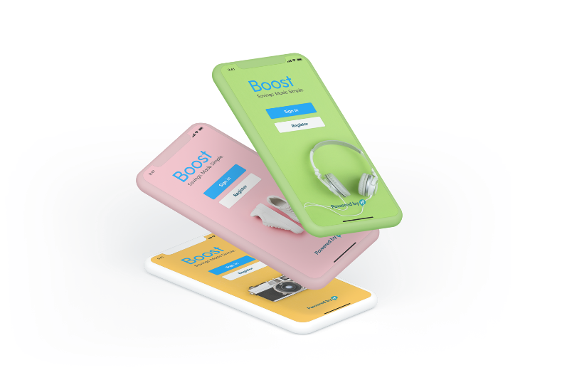

There are three easy ways for staff to access instant discounts:

Boost App
With the Boost App you have access to all discount codes in the palm of your hand. When you are out and about you can quickly and easily see retailers offering discounts and specials. You can also receive notifications about limited time offers. Made for both Apple and Android phones and available from the app store.

Boost Website
You can view all offers and discounts online and download vouchers for instore redemption. If using an online retailer or service provider, you can view discount codes to apply the discount at checkout.

Boost Email
Special offers and exclusive promotions are promoted through email – such as Noel Leeming sales and getaway specials from Millennium Hotels and Resorts.

Learn more at www.myboost.co.nz

Your Boost Login
To register for Boost please download the Apple or Android App or register on the website using the below information.

Boost App ID: Boost App ID

Boost PIN: Boost PIN

Apple App: https://apps.apple.com/nz/app/my-boost/id1468787984 or search “My Boost”

Android App: https://play.google.com/store/apps/details?id=com.n3.myboost or search “My Boost”

Website: https://www.myboost.co.nz/register-activate-card

Boost is powered by n3, New Zealand’s largest business buying group. Boost is optional and provided for your personal use exclusively by n3 Limited. Company Name have a commercial relationship with n3. The Boost user terms and conditions can be found here: https://www.myboost.co.nz/about-boost/boost-user-terms-and-conditions including privacy protection: https://www.myboost.co.nz/privacy-policy

